***Documentation***

**Title:** Ministria e Inovacionit dhe Ndërmarrësisë

**Project description:**

Aplikimi i Internet of Things në Praktikë. Zhvillimi i prototipeve inovative ne: Smart Farm, Smart Home, Elektronika ne Shkolla

**Activities:**Key activities:

* Researching and purchasing materials.
* Promoting and selecting participants and schools.
* Implementing training sessions and developing products for each component.
* Supporting training for teachers and students.

**Photos:**

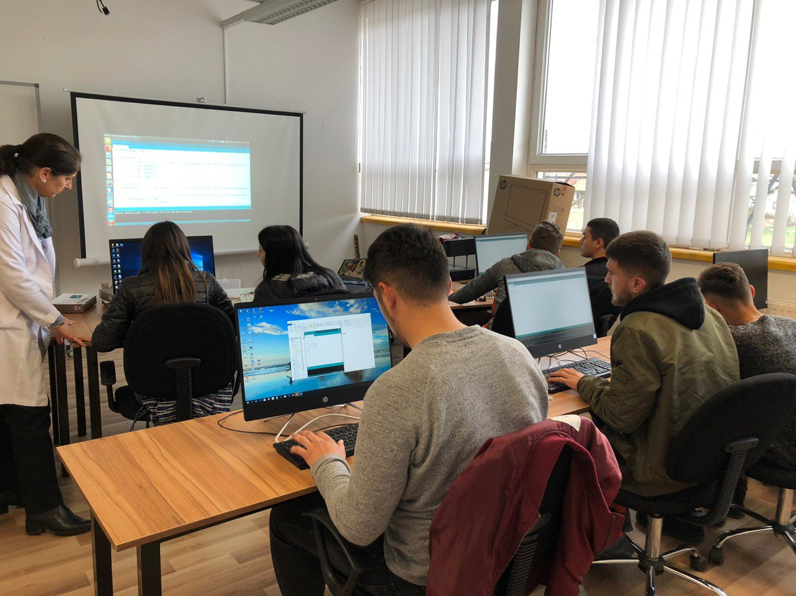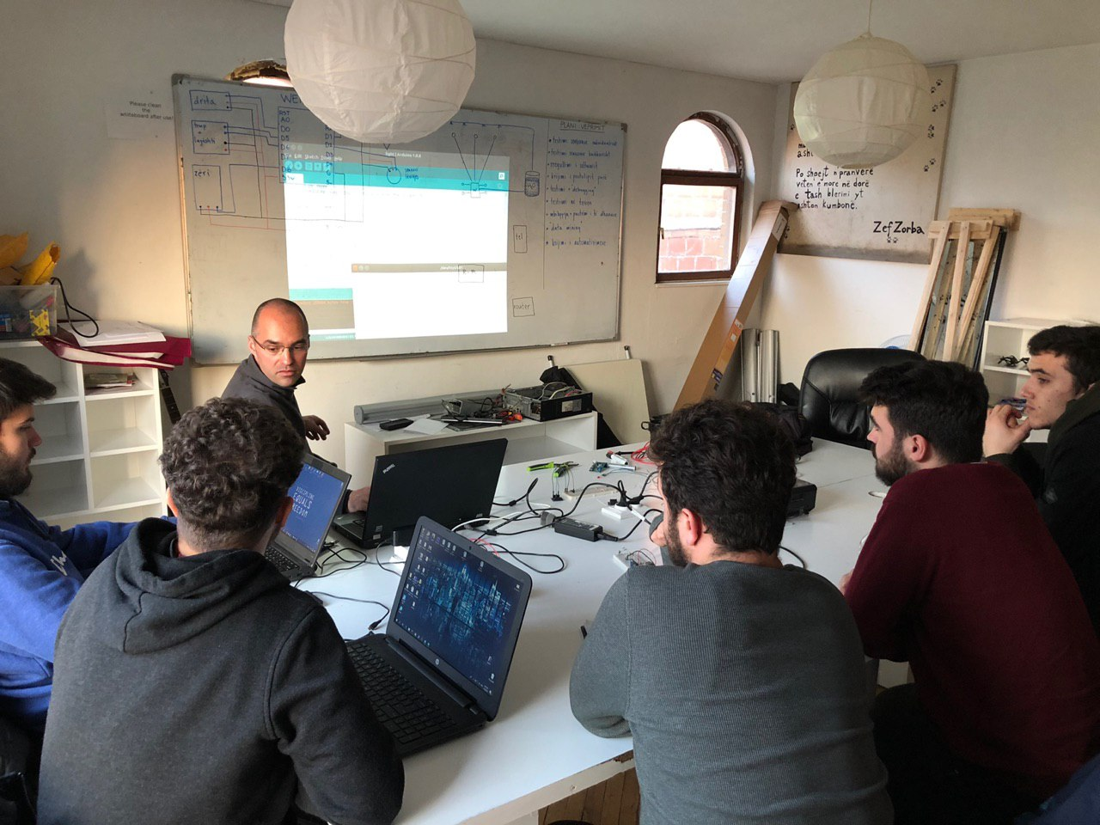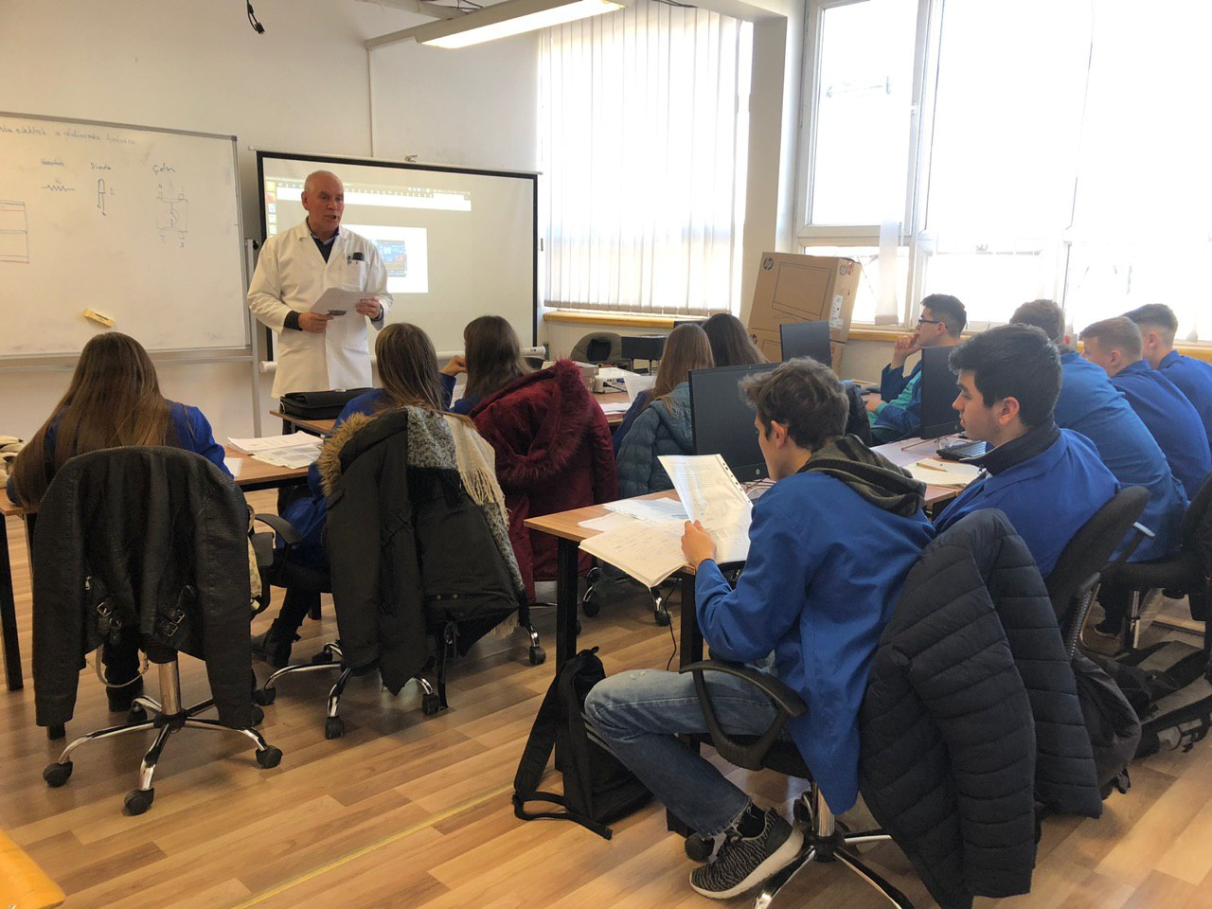

**Beneficiaries:**

A total of 127 individuals benefited, including participants in Smart Home and Smart Farm, teachers from partner schools, and students who attended the training sessions.

**Partners:**

* N/A

**Budget:  
€15,000**

**Project duration**:

Dec 2018 - June 2019

*This document is FLOSSK intellectual property - Do not share without authorization from FLOSSK.*